Euromech Colloquium n. 541
New Advances in the Nonlinear Dynamics and Control of Composites for Smart Engineering Design
Senigallia, Italy, June 3-6, 2013

Title of the Paper

S. Lenci
Polytechnic University of Marche, Italy, lenci@univpm.it

J. Warminski
Lublin University of Technology, Poland, j.warminski@pollub.pl

Abstract. Please write here the abstract of the paper. Times New Roman fonts, 10 pts, justified. You can cut and past the accepted abstract or you can change it according to your wishes.

Introduction
Use A4 format (210 x 297 mm). Upper, bottom, left and right margins: 35 mm.
All text should be in Times New Roman fonts. Title 14 pts left aligned, authors 12 pts left aligned, affiliation and email 10 pts left aligned, abstract 10 pts. justified, main text 11 pts justified, references and acknowledgements 10 pts justified.
The paper should be prepared according to this Word template (which fulfil the previous requirements) and submitted as a WORD file. This will help us to edit it in order to have homogenous proceedings, which will contain only PDF files.
A Latex version reproducing this template can be accepted, although we discourage the use of Latex.
The are no limitations to the paper length, but we suggest all authors to be concise for the benefit of the readers. 10 pages could be an adequate length.
References should be labelled according to [1], [1-3], [2,4].

Main sections
Please organize your paper as commonly done. Start with the introduction, then the main bodies, and end with the conclusions.

Subsection
You may have subsections. Please refrain from using sub-subsections.
You may have formulas, such as

$\text{sinh}(x)=\frac{e^{x}−e^{−x}}{2}$, (1)

to be referred to as eq. (1), tables, to be referred to as Tab. 1, and figures (see Fig. 1).

3 June 2013 | Monday
4 June 2013 | Tuesday
5 June 2013 | Wednesday
6 June 2013 | Thursday
Table 1: The days of the Colloquium.

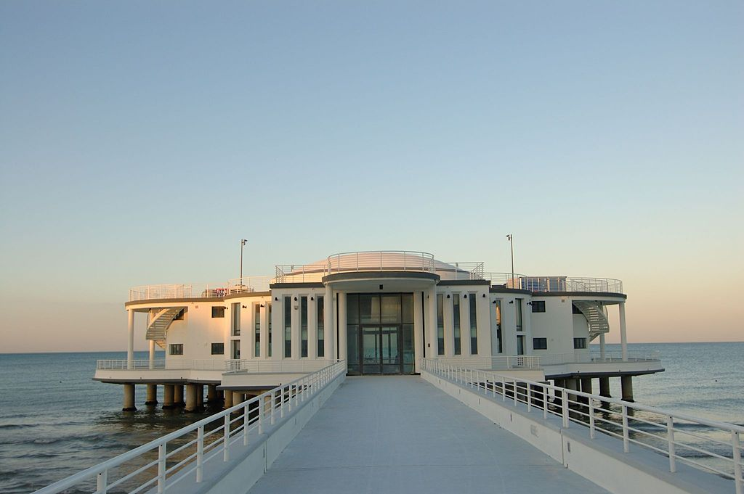
Figure 1. The Colloquium venue.

Each table should fit on a single page; please, limit the dimension of the file by using an adequate resolution for the Figure.
From time to time please have a look to the Colloquium website http://www.dipmat.univpm.it/euromech541/ to check for some news.

Conclusions
The paper must be send as an attached WORD file to lenci@univpm.it. The deadline is March 20, 2013.
We remind you that the paper is NOT mandatory.
We will print the booklet of accepted abstract, which you will receive at the Colloquium together with a CD or a PENDRIVE with the conference papers. It will have an ISBN code, and so it will be valid as conference proceedings publication.
Note that the Scientific Committee reserves the right of not accepting a proceeding paper if considered inadequate, in spite of the acceptance of the abstract.

Acknowledgements. We wish you a nice and fruitful Colloquium, and a nice permanence in Senigallia.

References
[1] L. Jun, H. Hongxing, Free vibration analyses of axially loaded laminated composite beams based on higher-order shear deformation theory, Meccanica, 46 (2011) 1299-1317.
[2] J.D. Achenbach, Wave Propagation in Elastic Solids, North-Holland Publishing Company, 1973.
[3] S. Lenci, A simple model for pedestrian induced lateral oscillations of bridges, Proceedings of the 4th IEEE International Conference on Nonlinear Science and Complexity, 6-11 August 2012, Budapest, Hungary. ISBN 978-1-4673-2701-5.
[4] N. Surname, Title, www.ontheweb.com/this.

